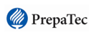
Instituto Tecnológico y de Estudios Superiores de Monterrey
Matter and sustainability
Enero-Mayo 2026
Prepa Tec
Study Guide
- What is a polymer?

- Why are some fats solid at room temperature (margarine) and others liquid (vegetable oil)?

- What are the risks of benzene exposition?

- When and how do we use ortho, meta and para indicators?

- Which organic compounds are considered derivatives of water?

- Why is methanol soluble in water but methane isn’t?

- Draw an example of a primary, secondary and tertiary alcohol.

- Draw the structure of the smallest ketone

- Why did we use potassium dichromate on practice number 2?

- Complete the summary table.
Name | Functional group | Main uses and sources. Common examples | Nomenclature (ending) | Name of Reactions
Aromatic

Alcohol

Ether

Aldehydes

Ketone

- Write the name and classify the next molecules according to their functional group (If you come across an aldehyde or ketone don’t name them only indicate their functional group)
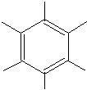 |  | 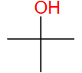
 | 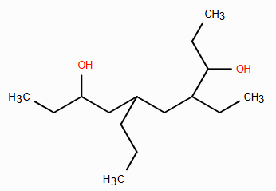 | 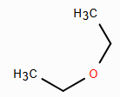
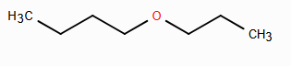 | 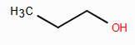 | 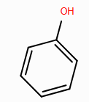
 | 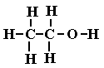
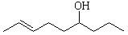 | 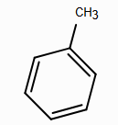

- Draw the following structures
- Methanol
- Nitrobenzene
- p-dichlorobenzene
- Isopropanol
- Ethyl methyl ether
- Phenol
- 3,3-dimethyl-5-phenyloctane
- 3,4-heptanediol
- 3-propylphenol
- Propoxy butane
- 2,3-cyclohexanediol

- Write an example for each of the following reactions. Draw the structure of reagents and products, name them and indicate the catalyst needed.
- Bromination

- Chlorination

- Nitration

- Sulfonation

- Friedel-Crafts Alkylation

- Friedel-Crafts Acylation (Only the structures, we need to get to ketone nomenclature to name this one)

- Hydration of alkenes

- Fermentation

- Dehydration

- Oxidation (primary and secondary alcohols)

